|  |  |  |  |
| --- | --- | --- | --- |
| Name | school | task no | unit |
| Zeyad Emad | We School | 2 | 6 |

INTRODUCTION

A client asked me the owner of the security system company to create a website for his company and that this site is simple and uncomplicated for the client and I offered him several projects, so he chose to have his site consisting of one page consisting of 5 sections, section for "Header" and section for "about" and section for "products" and section for "contact" and from here began work on the project.

**URL:**[**https://2e2o77.github.io/Security-System/**](https://2e2o77.github.io/Security-System/)

HOW TO CREATE A WEBSITE?

* The user asked me that the basic color be a degree of blue and the site should be simple and easy to use for the visitor
* Header:

The first thing I started with was the header and we created the navigation bar and it consisted of the company's logo and a list to navigate the site and a login button

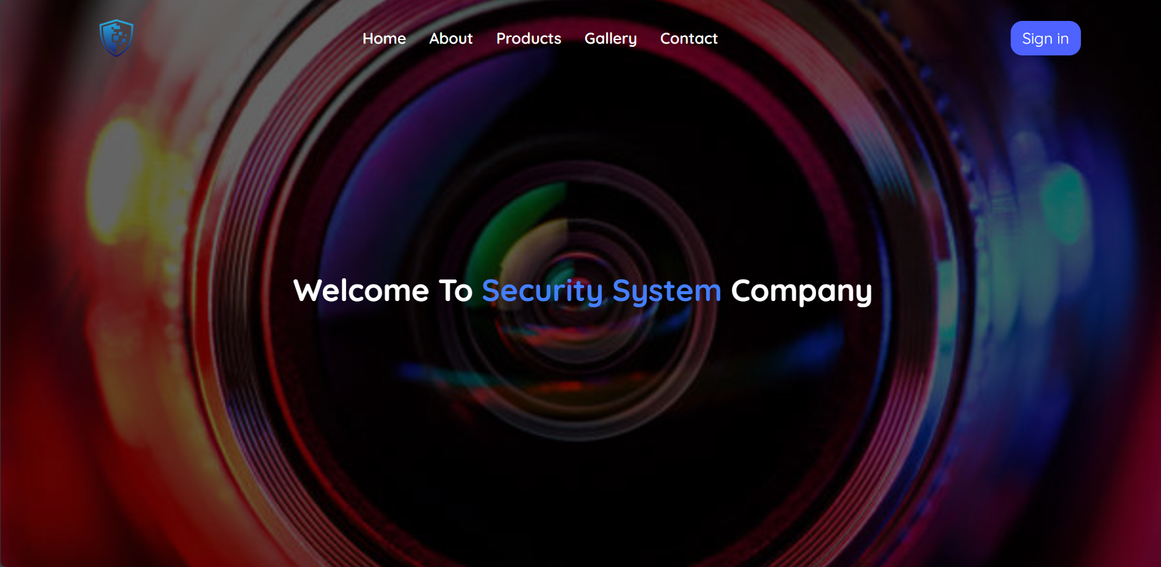 And his sentence in CSS is as follows

Then after the navigation bar the company name in the middle of the page and this was the final output of the page.

* 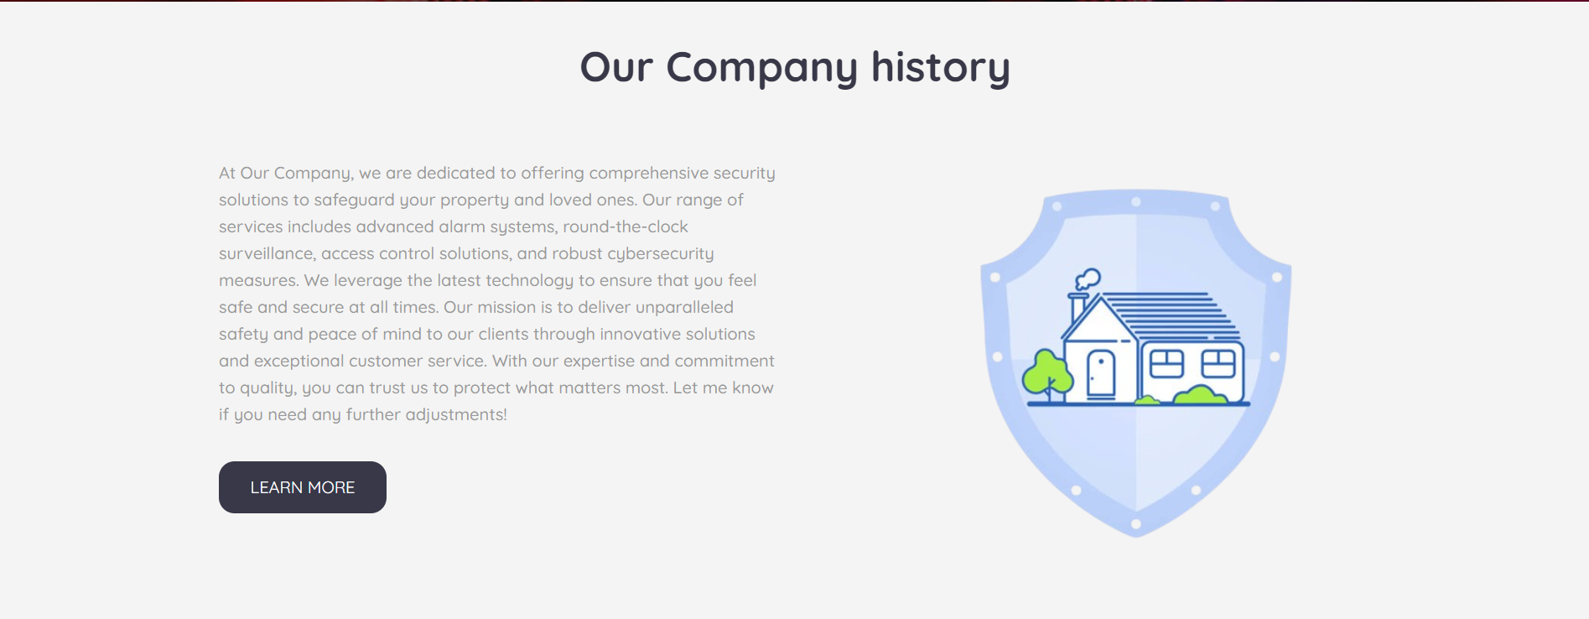About Section:

And then section "About" and this section was simple as it consisted of a paragraph about the company and a picture that expresses the security system This way.

* Product Section:

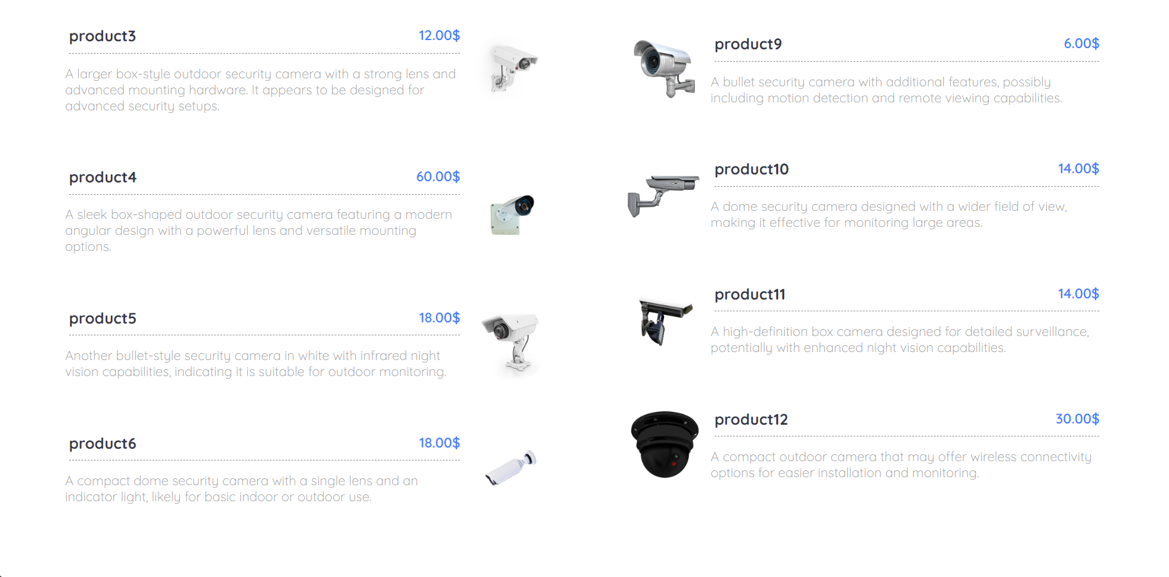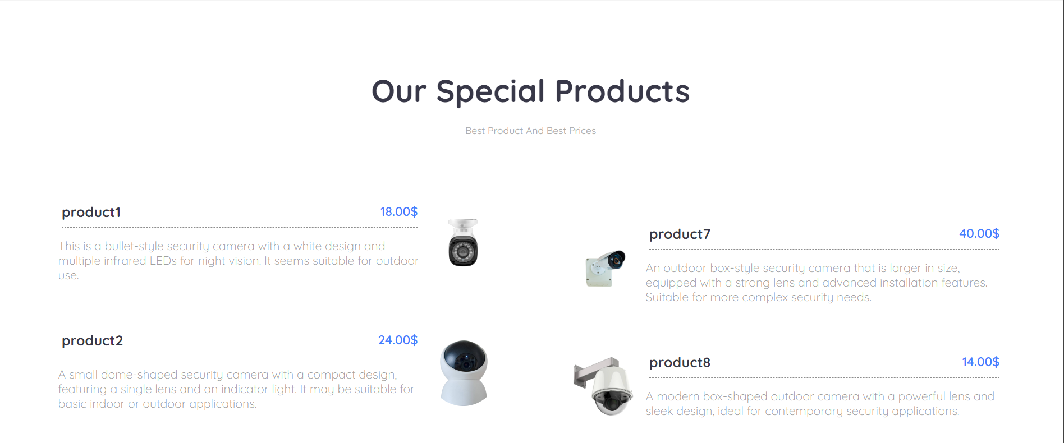The products section was the most difficult and the most complex as it consisted of a div for the title and a div for the products on the right and left and inside the div 2 div a div for the products on the right and a div for the products on the left so that it is easy to control its design in CSS as follows.

* Gallery Section:

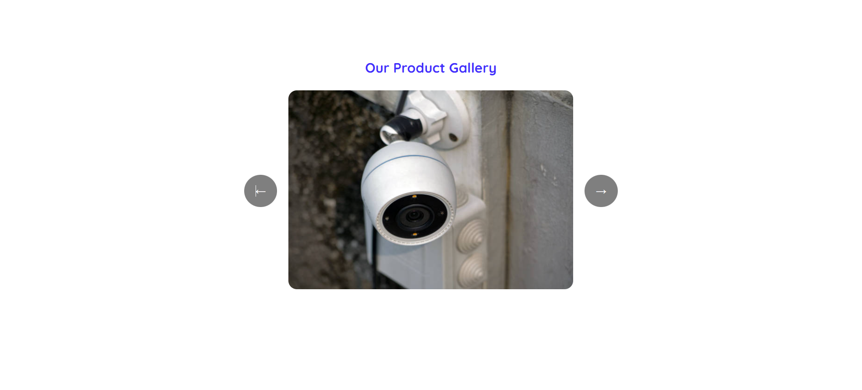 In the Gallery section, I used JavaScript by making slide-Show so that it provides space on the site, and this was a request from the customer.

* Contact Section:

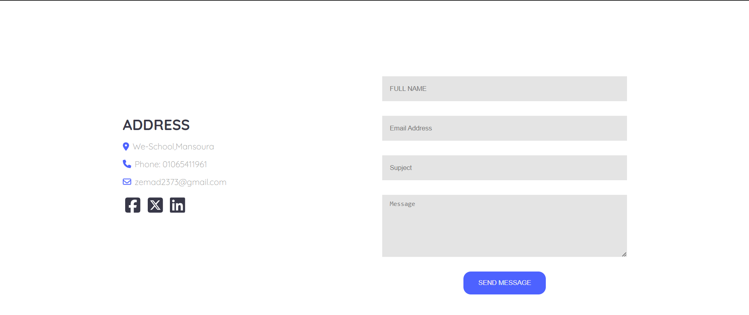The contact section I created to help the customer log in and save his information. This was a request from the customer, so I created it in HTML, designed it in CSS, and added JS codes to it so that if the customer left something blank, the site would inform him to please enter or fill out all your data, and also if something wrong was written in the email. The site tells him to write the email correct, in addition to a description of the company, the address, and the social networking sites as follow

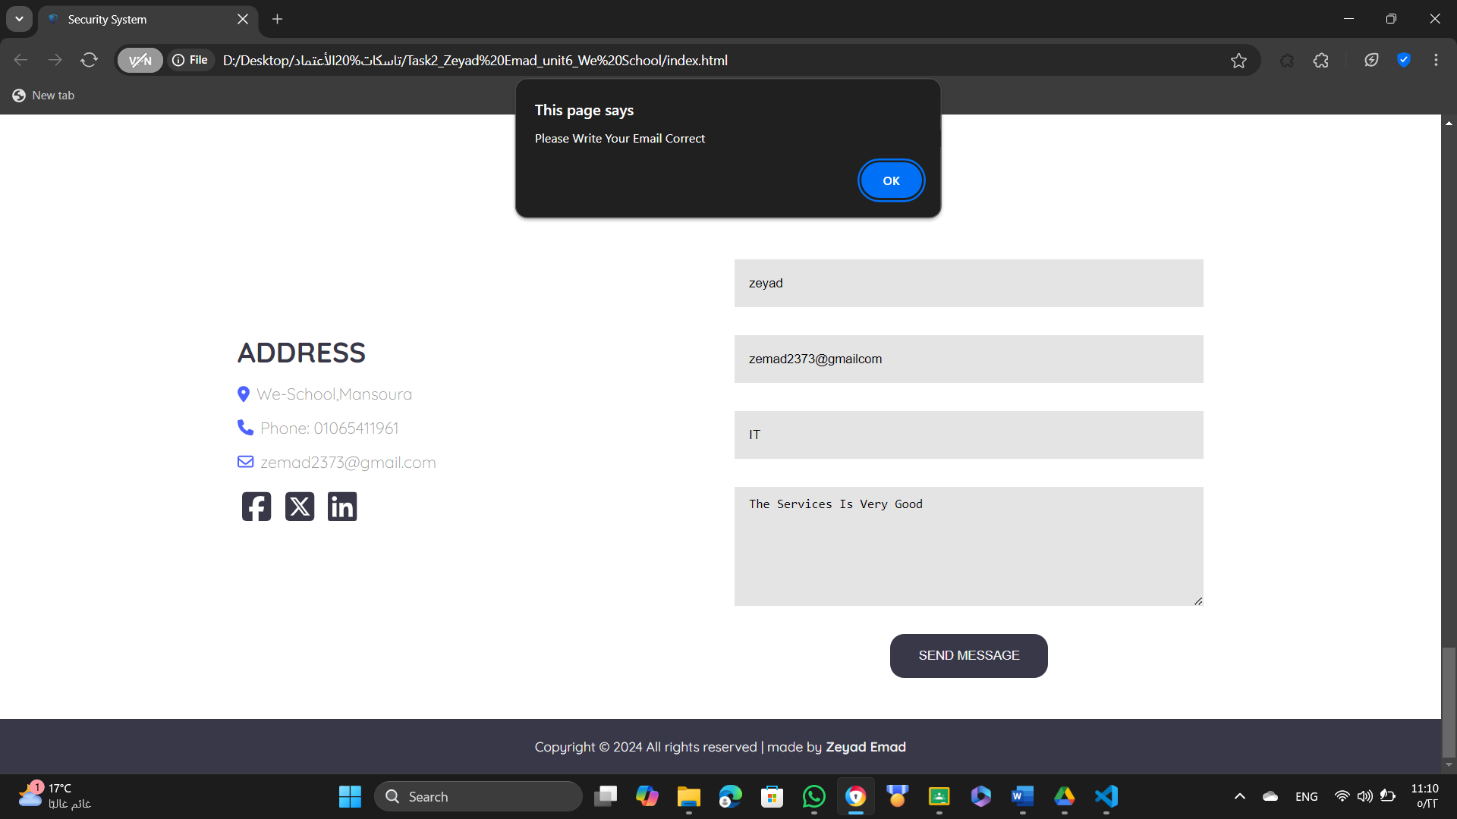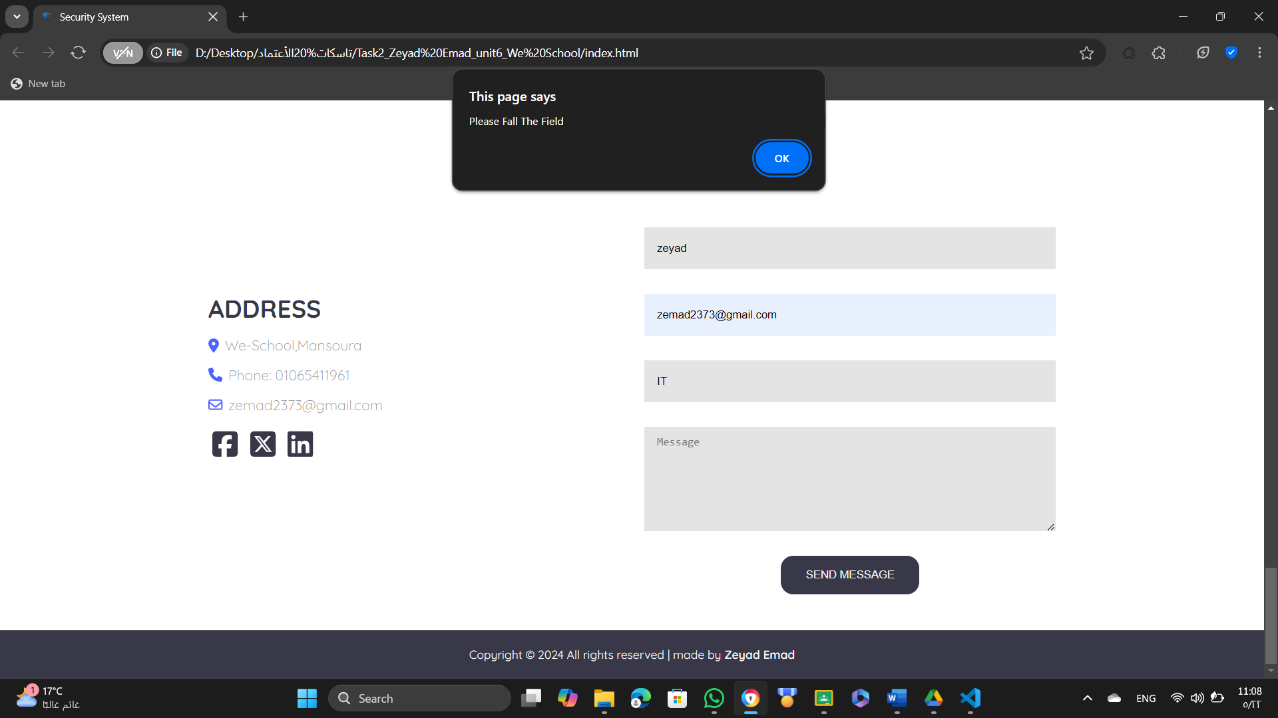3RD)Alternative design options:

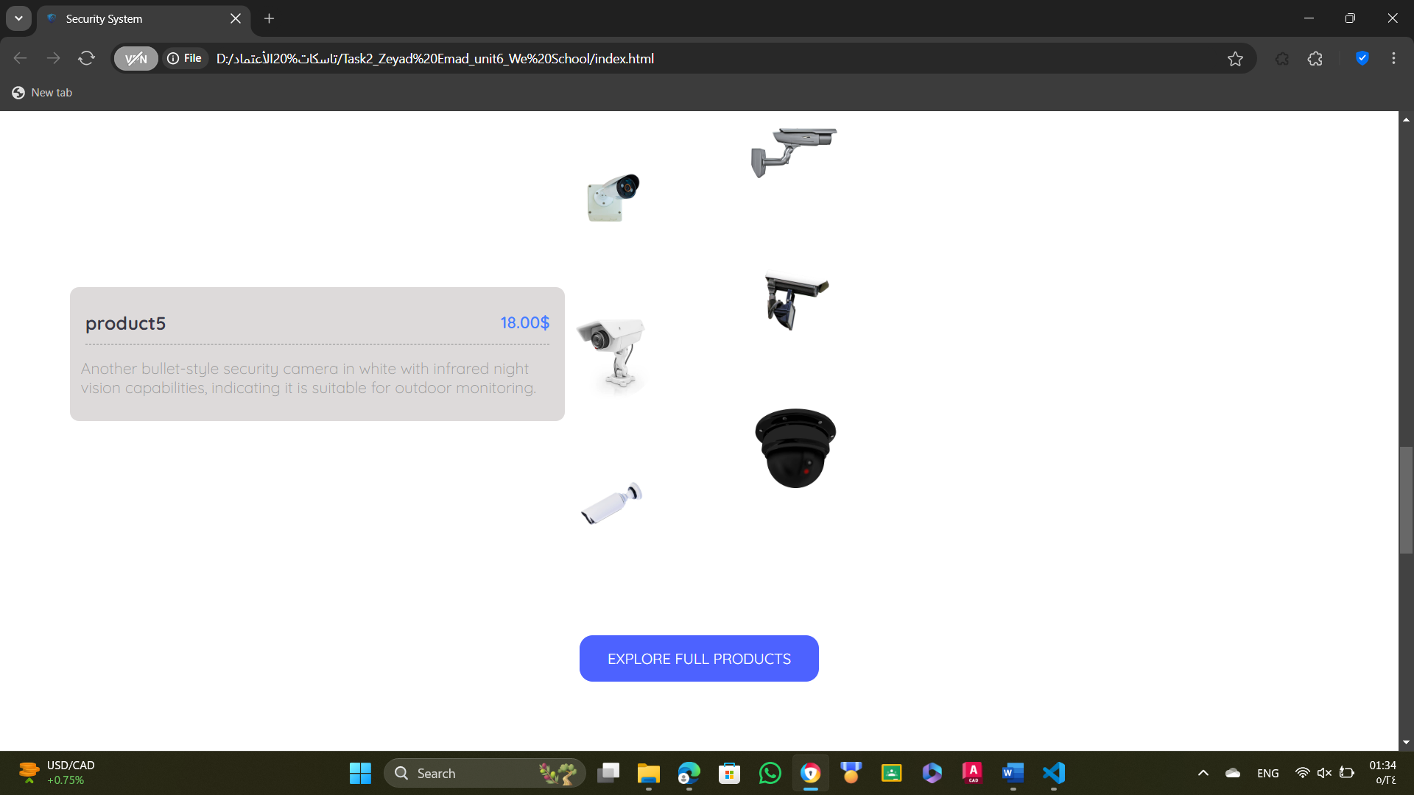The client asked me to modify some things like making the products section more interactive, so I tried in it until I made the text div disappear and when I move the mouse on the container the words appear and make a movement, He also asked me to improve him in the Slide-Show so I had to do it with Bootstrap as follows

Product Section

Gallery Section (Slide Show)

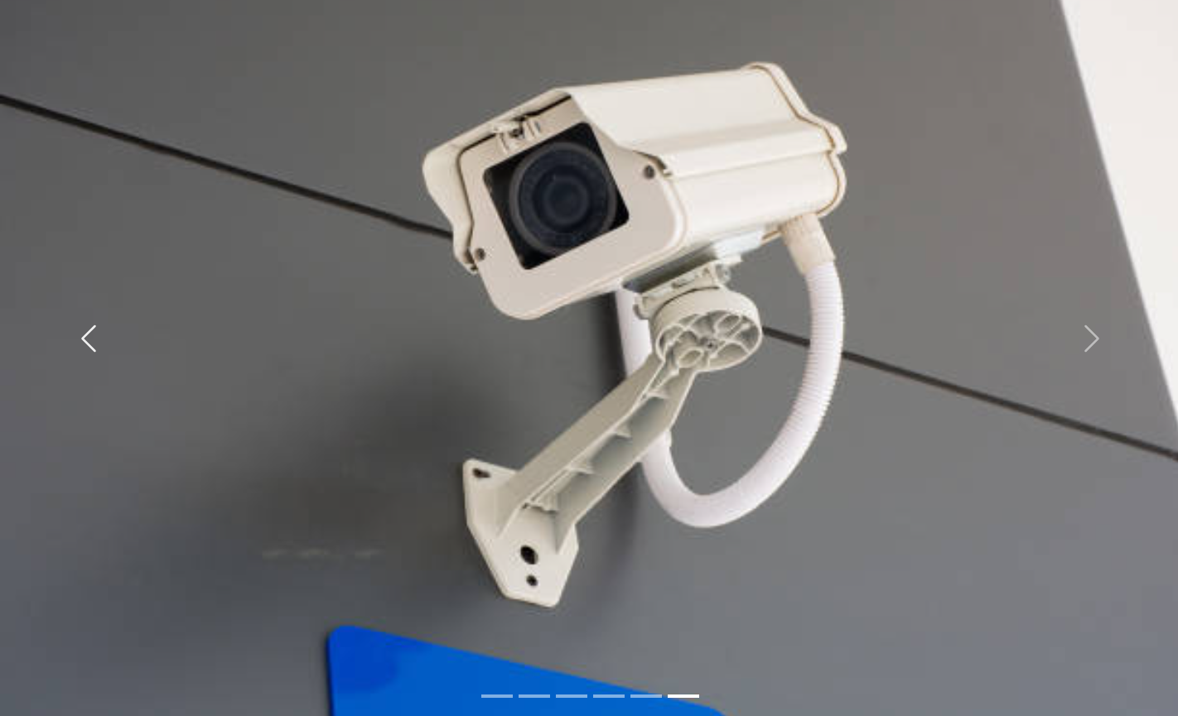

4th) Technical documentation:

1. Tools: HTML, CSS, JS, BS

|  |  |
| --- | --- |
| HTML | HTML (Hypertext Markup Language) provides the foundation of any website. It structures content like headings, paragraphs, images, and links. Think of it as the skeleton that organizes and displays information, setting the stage for styling and interaction. |
| CSS | CSS focuses on developing the aesthetic of the website. This defines colors, fonts, spacing, and layout, which make the page appealing. You will achieve responsive designs, perfect alignment of elements, and consistent styling across different screen sizes with CSS. |
| JS | JavaScript animates and makes things happen on websites. It powers animations, form validation, and changes to content on the page without requiring a full page reload. Listening for events, JavaScript brings life into pages, adding behavior that enhances user experience. |
| BS | Bootstrapping is a powerful framework that simplifies web design. It provides pre-designed templates for buttons, forms, and grids. Bootstrap ensures responsive layouts across devices, speeds up development, and maintains a professional, consistent look with minimal effort. |

1. Browser: